**PASS Mock Midterm**

Time: 35 mins

Create a program which capitalizes a variable length string input by the user. You cannot use the inbuilt python function that capitalizes the letters.

Create a python file in VS Code called *ENDG233_mock_midterm*. Start by first making a main function where you ask the user for their input and which then calls the function you use to capitalize the input called *capitalize_input*. The function receives the user input. The capitalized input is then returned to the main function and printed from the main function.

In your program you must use all of

* If/elif/else statements
* Loops (for or while)
* Functions
* Any of: list, dictionary, set, tuple, string and the functions associated with them. Ex. .append(), list[index], etc.

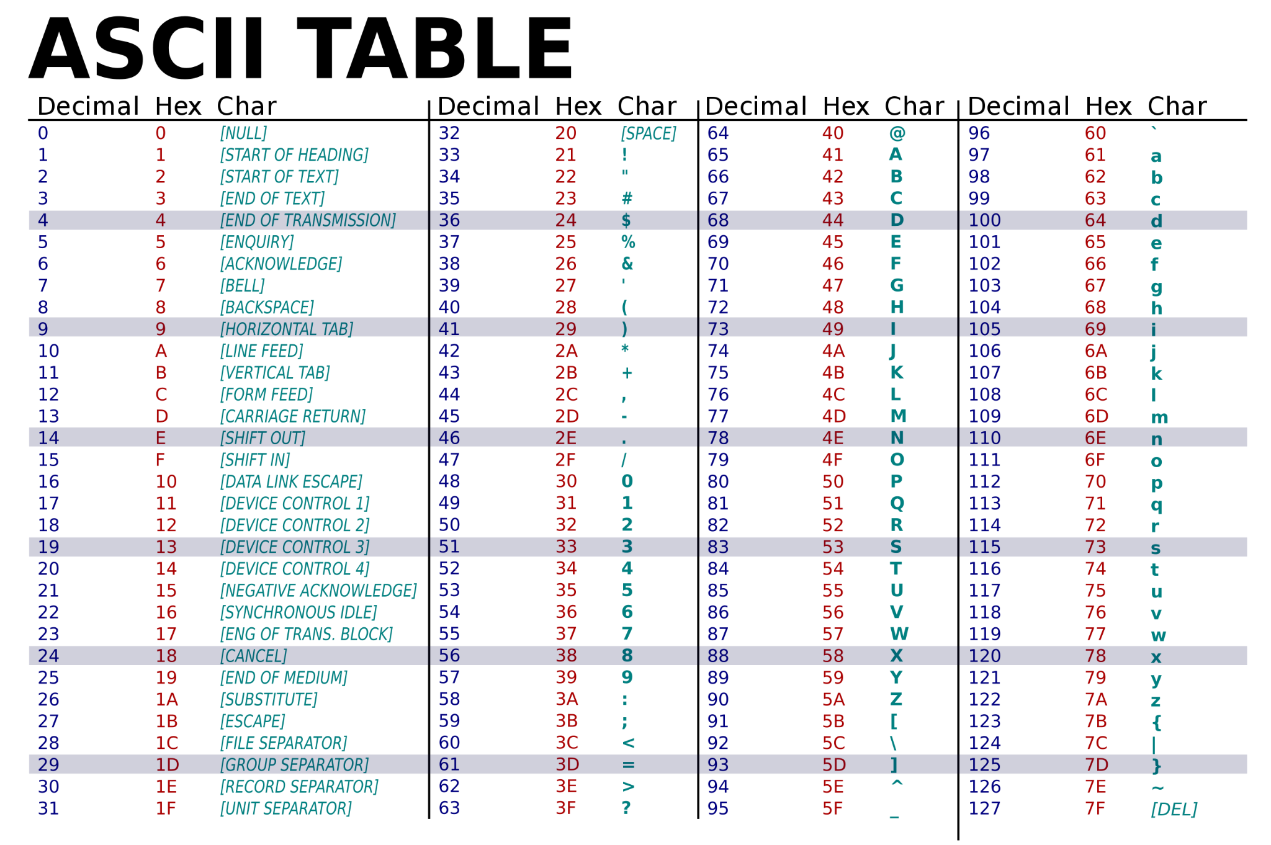

**Sample Output**



**Things to consider**

* Python variable naming conventions
* A string is immutable. How will you store the capitalized string?
* Already capitalized letters
* Non alphabet characters should remain unchanged. Ex a 9 should stay a 9.